BROADWOOD AREA SCHOOL
MIDDLE SCHOOL SCIENCE
TERM 3 2014
STRAND: NATURE OF SCIENCE
DESCRIPTION: Students will learn how to do a Fair Test Investigation

BLOOM’S TAXONOMY
KNOWLEDGE: To Know the Terminology of Fair Test Investigations.
COMPREHENSION: Knowing how to APPLY the Fair Test Terminology
APPLICATION: To Apply the Knowledge and Understanding of Fair Test NoS
ANALYSIS: To Analyse of the recorded data
SYNTHESIS: To synthesise a comprehensive Discussion of the Fair Test Investigation
EVALUATION: To Evaluate the Fair Test Investigations.

RANDOM EXAMPLE OF A SCIENCE FAIR PRESENTATION BOARD

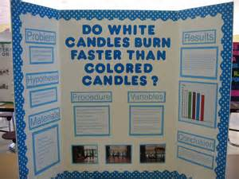

In the above picture you can see an upright, folded, cardboard-stand on which a Science Fair Project is presented. Elements ( things ), that make this presentation look good, include the following:
- The title of the Science Fair Project is easy to read and understand; however, it is too BLUE. It is clear that the student have used five different coloured candles. He could have used the five colours evenly to adorn his presentation.
- The lay-out of this Science Fair Project has seven headings, i.e. (1)Problem (Aim); (2)Hypothesis (3)Materials; (4)Procedure (Method); (5)Variables (6)Results and (7)Conclusion. The lay-out is well-spaced and neat.
- There are 3 pictures in the presentation. Pictures add much visual quality to any presentation.
- There is a graph (bar-graph). It is very scientific to present your data on a graph. A graph is an example of processed data. It is easier to interpret processed data than to interpret raw data.
- The process, prior to this presentation, may have included the following: (1)Choosing something to investigate; (2)Planning how to investigate that something; (3)Asking the teacher’s approval; (4)Listing the materials and equipment for the teacher to arrange; (5)Following the plan and finishing the investigation; (6)Making sure that EVERYTHING is recorded in a logbook ( your plan, successes, mistakes, changes made, thoughts, help from others, data, drafts, etc. ); (7)Presenting the FINAL SCIENCE FAIR PROJECT onto a Science fair Board ( like the one in the picture )
Glossary of Fair Test Terms and Definitions
TERM | DEFINITION
Phenomenon | An interesting happening or occurrence in nature that makes us wonder about things.
Hypothesis | A guess that we take to explain a certain phenomenon.
Aim of Experiment | The goal or purpose of the experiment. A sentence describing what we will be trying to prove in the experiment.
Plan of Method | A planned recipe that I will follow to do the experiment. The recipe can be in the form of a labelled diagram and written korero.
Beginning variables | The variables I have control over in the beginning. The variables that will go on the X-axis. ( Independent Variable )
Controlled variables | The variables that I keep constant to make sure that the fair test stays fair. ( Dependent Variable )
End Variables | The variables that I will get as results at the end of the experiment. The variables that will go on the Y-axis. ( Dependent Variable )
Measure | To take the value of a variable e.g. length, mass, weight, volume, temperature or count of a variable.
Trials | To test ( tutu ) certain things while you plan a Method of an Experiment.
Materials + Equipment | A checklist of all the stuff you will need to successfully complete the experiment. You can draw up the checklist from the method that you have planned.
Experiment | To find out something that you think you know the answer.
Changes to Experiment | Things you all of a sudden decide to change in your planned method when you do the experiment, just because you think your new idea will work better.
Results | The measurements you get at the end of the experiment.
Raw data | The measurements that are all written on a table, which do not make sense yet.
Processed data | A graph which shows what the raw data means.
Line-graph | A line on graph paper that goes more-or-less through the plotted dots.
Bar-graph | Columns on graph paper.
Pie-graph | A circle with segments showing portions.
Conclusion | A statement that confirms the Aim of the Experiment.
Discussion | A summary that brings the whole Investigation together.
Evaluation | A discussion that points out the validity of the Investigation; but also the limitations; and possible improvements when this Investigation is repeated.

STUDENT INSTRUCTIONS
STUDENT INSTRUCTIONS GLOSSARY
3-D accessories = stuff you can place in front of your board
captivating = to get someone’s attention
comprehensively = ‘thoroughly, and in great detail’
conclusion = what you made up your mind about
detailed reading = to read everything
discussion = korero
draft form = rough notes
facilitate = to help
final method = the method that was planned, done and changed a bit all together nicely printed out.
hypothesis = a guess
limitations = things that made it difficult
logbook = journal
logbook entry = what you write in your logbook
phenomenon = something that happens
presentation = to show
presentation board = a cardboard fold-up board you can buy from front desk
presentation manual = A book that has all the details you did not want to put on the presentation board
processed data = lines or bars in a graph
raw data = numbers in a table
scan-reading = fast reading ( a bit here and a bit there )
succinct = short and to the point
table = grid
validity = how much it can be trusted

STUDENT INSTRUCTIONS: STEPS
DO FIRST
Identify many phenomena. Ask at home before you ask the teacher for ideas. We are always looking for fresh ideas from the people at home. The teacher will tell you what to do with your fresh idea. Make sure that the people at home understand what a phenomenon is. Ask the whanau about strange phenomena that they may have observed over the years at their work, sports, making food, fishing, gardening or anywhere.
DO SECOND
It is up to you to choose ONE phenomenon to investigate. Consider all the phenomena and the hypotheses, that the whanau came up with, and choose which one you will investigate. Choose the easiest one to do, but go for the most interesting one. Your family members can help you to decide which topic is the most interesting. The Science Fair Project is part of your September progress report and counts 50 marks.
DO THIRD
Share your ideas with your friends at school. Choose only the best ideas. Choose ONE peer, to work with you on ONE topic.
How to score high marks in your Science Fair Project
A total of 50 marks will be given, which will be broken up as follows:
- Introduction: 10 marks
- Method: 10 marks
- Results: 10 marks
- Conclusion: 2 marks
- Discussion: 5 marks
- Log Book: 3 marks
- Presentation: 10 marks
TOTAL OF 50 MARKS FOR THE END OF UNIT TEST ( EOUT )
A good Introduction
- The Introduction should tie in with the Phenomenon.
- The Introduction should tie in with your Hypothesis.
- The Introduction is usually a short explanation of what this investigation is about.
- The Introduction should be captivating.
The Final Method
- You will start with a Planned Method in your logbook (in a draft form ); then you will type the Planned Method as a “Word” or “Pages” document and email it to Matua Carl to approve; then you will do the investigation; you may make a few changes, but you will have to record the changes in your logbook.
- The Final Method is the approved and edited version including the changes; if you put a shortened version of the Final Method on the Presentation Board, you should put the full version of the Final Method in a Presentation Manual ( a book that has ALL the details and more; this book may be on the table in front of the Presentation Board )
- It is always good to complement your Method with annotated diagrams ( drawings ) to facilitate the understanding of the judges.
- The Method should be user-friendly ( people can easily understand )
Good Results…
- are usually in the form of both Raw Data and Processed Data; the most important data for the Presentation is the Processed Data.
A good Conclusion…
- “sounds like” the Hypothesis and the Aim.
- is usually concise ( succinct; short and to the point ).
A good Discussion…
- helps the reader to understand the whole investigation;.
- brings the whole Investigation together.
- is usually where the reader should start to read.
A good Log Book…
- is not necessarily neat and tidy.
- has information in a draft-form.
- can help the judges to fill in some of their understanding
- has the same information as in on the Presentation Board.
- has recorded dates with each logbook entry.
- shows successes as well as failures.
A good Presentation…
- has colour…
- is visual ( has photos / graphs / drawings )
- could have supporting 3-D accessories
- could have a Presentation Manual ( Has all the typed detail. )
- has a captivating Title…
- is user-friendly ( easy to understand )
- caters for scan-reading on board
- caters for detailed reading in Presentation Manual.
NATURE OF SCIENCE
Q)What is the abbreviation for Nature of Science?
Q)See if you can see some of the Terminology that we have used and understood, so far, in the diagram.
Q)Make ONE deduction from this “schematic representation” of the Nature of Science.

SCHEMATIC PRESENTATION OF NATURE OF SCIENCE

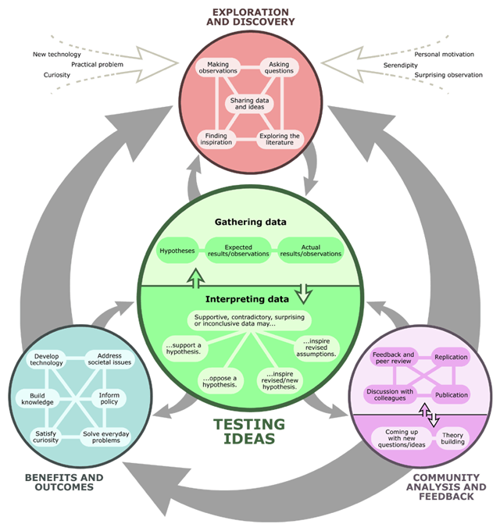

Choosing a Topic
We are always looking for new phenomena. The best people to ask are the older members of our whanau. They must have seen many strange things in their lives and never bothered to investigate it. We must be able measure the beginning variable and measure the end variable. Examples of measuring is to measure the distance; to measure the weight; to measure the time; to measure the light intensity; to measure the electrical current etc.

A Good Start in Choosing a Topic
Google the following: Science Fair and click on Images. You will see many Presentation Boards with many Investigation ideas. We are encouraging you to come up with a new topic, but if you cannot be bothered, you may choose a common one and try to make it your own. If you still cannot find a topic, that you feel comfortable with, you should ask Matua Carl for an idea.

 | Things To Do: Checklist
1 | Did you study the terminology glossary?
2 | Can you say one good thing about Science Fairs?
3 | Can you make one statement about the Nature of Science?
4 | Can you think of one phenomenon that you saw for yourself, without anyone telling you about it?
5 | Did you choose the most suitable person to work with you?
6 | Are you having regular meetings in your group?
7 | Does each member of the group know what he is supposed to do?
8 | Do you have your own logbook?
9 | Are you recording everything in your logbook?
10 | Did you explain the phenomenon-concept to the people at home?
11 | Did you ask the people at home if they have observed strange phenomena?
12 | Did you plan your time in such a way that you will finish your work way before the time?
13 | Did you receive a “Format-Template” via email from Matua Carl, and did you download it?
14 | Did you transfer the relevant draft information from your logbook to the Format-Template?
15 | Did you email your Planned Method to Matua Carl to be approved?
16 | Did you make a list of Materials and Equipment and asked Matua Carl to help you acquire what you need?
17 | Did you give a donation towards your Presentation Board?
18 | Did you do your Investigation and recorded all your raw data?
19 | Did you record any changes you have made?
20 | Did you finalise your Final Method and send it to Matua Carl to be edited?
21 | Is your work different from that of your mate, even though you have worked together?
22 | Do you have all the bits and pieces ready to me printed?
23 | Do you want to pay for a few colour copies from the office?
24 | Did you think about the colour scheme of the layout on your Presentation Board?
25 | Do you have enough time to cut and paste the bits and pieces onto your Presentation Board?
26 | Do you have your logbook to be placed in front of your Presentation Board?
27 | Do you have a Presentation Manual, to be placed in front of your Presentation Board, with ALL of the information and more?
28 | Did you ask your parents’ permission to go to the regional Science Fair in Kerikeri?
29 | Did you save some spending money for the trip to Kerikeri?
30 | Do you have the proper school uniform when we go to Kerikeri?

SCIENCE FAIR LESSONS
 | LEARNING INTENTIONS | SUCCESS CRITERIA | MATERIALS AND EQUIPMENT
1 | To study examples of Fair Test Investigations | Students will understand the format of Fair Tests; Discussion of Science fair Programme | Hard-copies; (Ipads) Facebook; Cabu; Google Drive
2 | To study Fair Test Investigation Topics | Students will broaden their understanding of Fair Test Investigations; Discussion of NoS | Videos; Hard-copies; Facebook; Cabu; Google Drive;
3 | To start with Planning of the Draft Methods of the Fair Test | Forming Groups, Planning Method, List Materials and Equipment, Place order with Teacher; send draft to CQ via email; CQ approve and give right-away to start | Logbooks (Ipads)
4 | To start with the Practical Investigations | Students prepare their Equipment and Materials
5 | To continue with the Practical Investigations | Students will do three sets of Experiments; take photos
6 | To finish off the Practical Investigations | Students finish off Processed data
7 | To finish off Written Components | Students finish off Discussion; Evaluation; Proof-reading
8 | To finish off Presentation Components | Students do proof-reading prior to printing | Presentation Boards; Glue; coloured paper; scissors; sticky tape; vivids; colour printer; Computer Room
9 | To do the Science Fair School Exhibition | Students will showcase their Projects | Exhibition in Gym; Prizes
10 | To revise the Fair Test Terminology | Students will combine Theory and Practical knowledge in preparation of EOUT | Fair Test Terminology Worksheets
11 | To make improvements on winning Presentation Boards | Students of winning Presentation Boards will prepare for Regional Science Fair.
12 | To write the Fair Test Terminology Test |  | Written Test
13 | To know about other forms of Investigations | Students will know about Pattern Seeking, Research and Model-building

