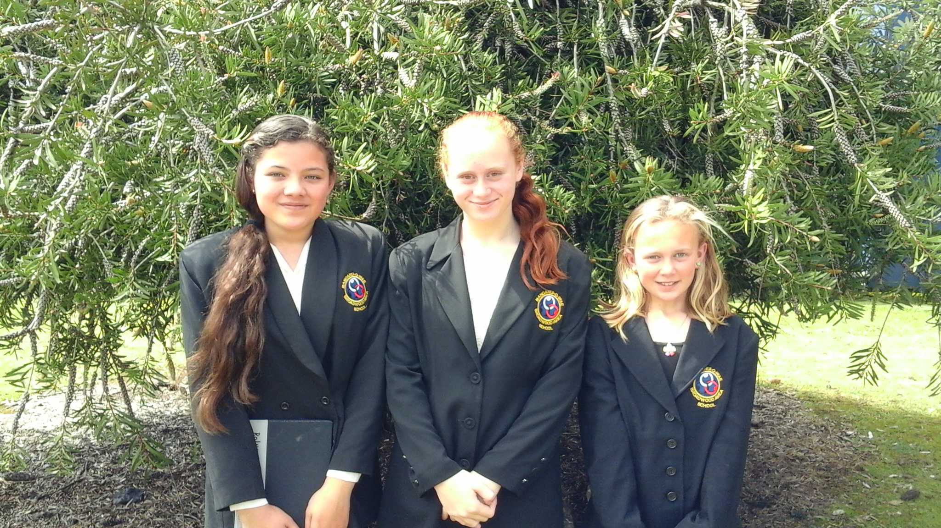
Our wonderful speakers just before they left for the Far North Schools Speech Competition at Pompallier School Kaitaia Tuesday 23 September, from left Tia Roberts, Brodie-Lee Barber and Jazmine Murray.
Tia’s topic was on “Mining our Landscape”, Brodie-Lee Barber about “Devices in Schools” and Jazmine’s topic was “Sideline Rules for Parents”. All were outstanding with Jazmine gaining the runner-up award in her category. Fantastic!!!

