Rising Stars at Broadwood

When it comes to accolades and achievements Broadwood Area School can make many claims. This year’s Sir Peter Blake Trust Award for outstanding leadership went to Year 08 student Tia Roberts. A rising star definitely, Tia has displayed extraordinary leadership throughout the year excelling in academic, sport and cultural activities, proving herself to be a wonderful ambassador of the school. The presentation was made by Westpac Trust Bank Kaitaia representatives Chad Merlo and Kyle Moana at a full school assembly, reflecting the importance of the award.

For the third year in a row well known star Jazmine Murray won the Years 1 to 5 English section of the North Hokianga Schools Manu Korero Competition held at Panguru. Jazmine is obviously a confident and competent speaker despite her years and is determined to build on these talents. Second place in the Years 6 to 8 English section went to John Alec Grbich with his topic You Only Live Once.

Hope Pihema rounded out the competition with first place in the Years 6 to 8 Maori section with her topic He Oranga Kotahi Anake. Hope, from Mangataipa, was awarded the prestigious Tamati Rudolph Memorial Trophy for her star performance in Te Reo Maori.

Broadwood students were delighted to participate in the Matariki Celebrations at the Te Ahu Centre last month organized by Whaea Mercia Smith. As well as enjoying the many workshops, Broadwood provided kapa haka and ura performances to a big and appreciative audience.

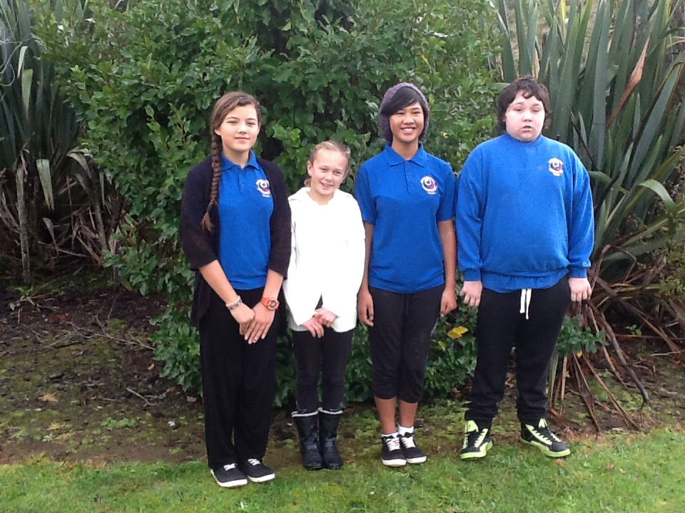
Broadwood’s rising stars from left: Tia Roberts, Jazmine Murray, Hope Pihema and John Alec Grbich

