Mountains there to see!!!

Months of planning and preparation paid off for some keen Broadwood explorers in August. For most it was the first time in the snow as they spent a week on the Central Plateau at Tongariro National Park, Highlights included being in a near white out, cooking a meal in a snow storm and trying out a toboggan. Visiting some of the famous landmarks including Te Kohatu o Hatupatu, Huka Falls, the site of the Tangiwai Disaster and the National Museum at Waiouru meant for an exhausting and fulfilling week away. “They were so excited from start to finish, it was such a huge journey for them all” says teacher Whaea Hurimae Latimer, “it did not take long for the t’shirts to disappear and the thermals to come out. It is so unique and different down there and so extreme for us coming from the Hokianga, it was a wonderful challenge for us all”.

Broadwood Area School would like to acknowledge Matua Kahuroa Sutherland, Whaea Linda at Mangatepopo Camp School and also the Oxford Sports Trust Whangarei whose generous support made this trip possible for the students of the school.

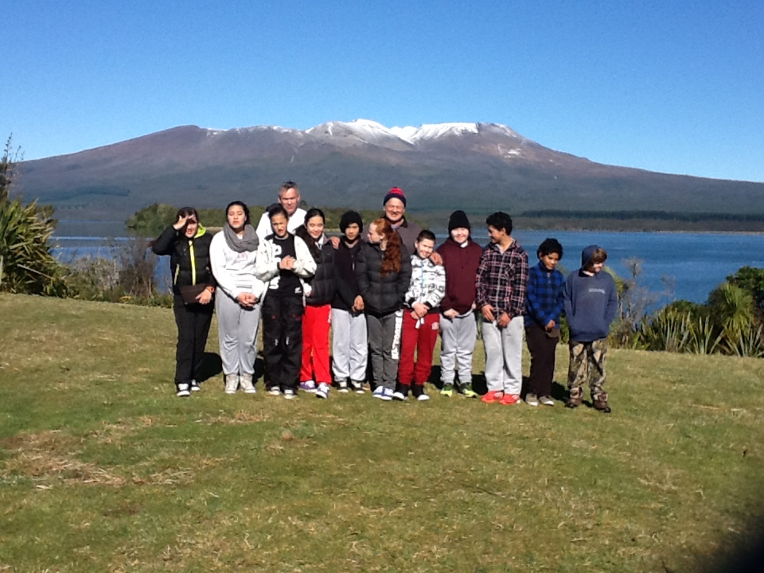
The Broadwood explorers with Mt Tongariro as a backdrop, from left, Tia Roberts, Krisharn Thompson, Ariana Adams, Jessica Wikaira, Hope Pihema, Brodie-Lee Barber, Marlon Frost, John-Alec Grbich, Cody Chapman, Soul Whaanga and Paora Proctor with staff Henare Gabel and Kahuroa Sutherland

