Broadwood runs across the North

If there is one thing Broadwood students excel at it is running away! So with an array of school cross country events on offer this season the school’s junior students have been doing just that. On a magnificent day at Mitimiti recently they gained many victories and placings in the North Hokianga Schools Championships. The excellent conditions and superb course meant for fast times and plenty of fun for the multitude of runners and supporters. All participants are congratulated for their achievements and especially our winners and place getters Zaria Murray, Tuaru Shortland, Jazmine Murray, Te Koha Shortland, Tiari Samson, Jessica Wikaira, Pouaka Skinner, Ariana Adams, Paora Proctor, Tia Roberts and Regan Skinner.

Next up was another great display at the Far North Schools event hosted by Peria School. Jazmine Murray took out first place in the 8 year girls section while her younger sister Zaria finished 5th. Ariana Adams, Tia Roberts and Tiari Samson also gained 5th placings in their respective events, all qualifying for the Northland Champs at Dargaville.

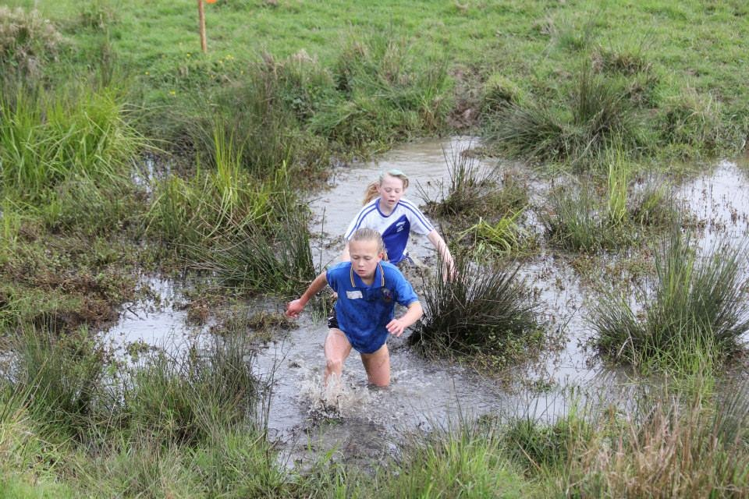
Jazmine Murray in the lead and the mud and slush at Peria

