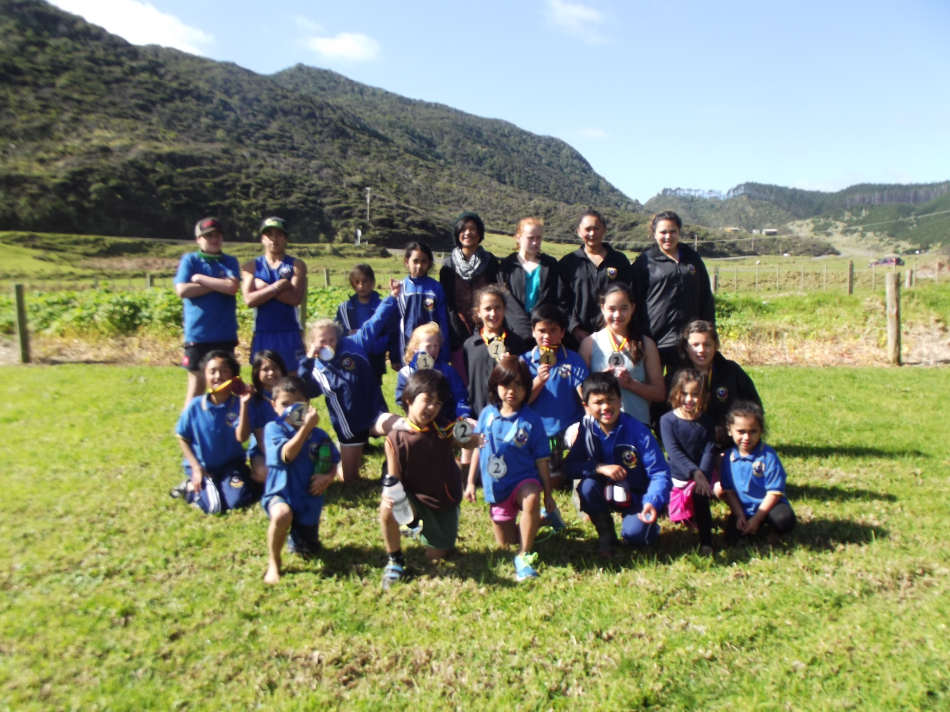
Some proud competitors on a great day at Mitimiti

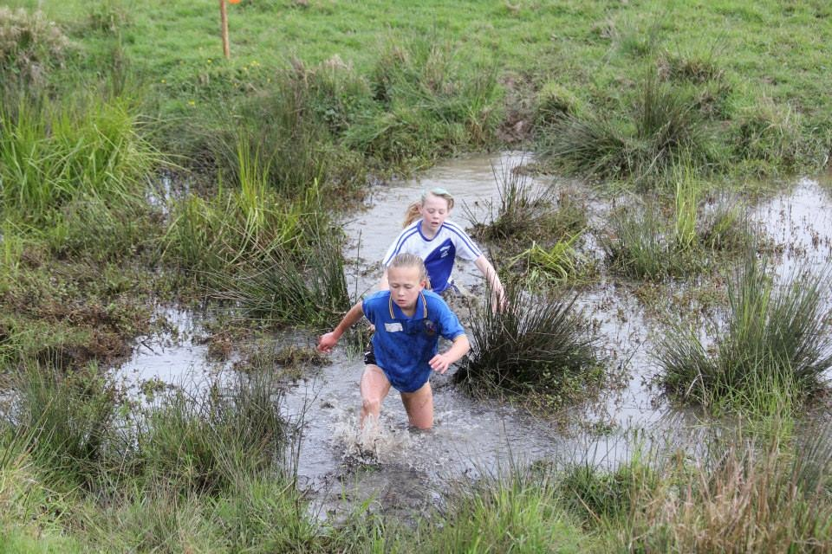
Jazmine Murray in the lead and the mud and slush at Peria

