WAIPUNARANGI
Panui W03/03
Kia ora koutou katoa Fri 29 Aug 2014

Tongariro Camp 03-08 August
By now you would have heard about our recent adventures to Tongariro. Congratulations to those students who contributed so positively to the trip. There were many highlights and first time experiences for our students along with a range of challenges unique to the Central Plateau. Whaea Hurimae, Matua Kahuroa and myself have appreciated the feedback from you and the acknowledgements from parents and whanau. We were very fortunate to stay at the Mangatepopo Camp School and be looked after by Whaea Linda. This trip would not have been possible without the generous support of the Oxford Sports Trust Whangarei.

North Hokianga Cross Country Mitimiti Friday 22 August
A fine effort by our students and staff resulted in a wonderful day. All participants are congratulated for their achievements and especially our winners and place getters Zaria Murray, Tuaru Shortland, Jazmine Murray, Te Koha Shortland, Tiari Samson, Jessica Wikaira, Pouaka Skinner, Ariana Adams, Paora Proctor, Tia Roberts and Regan Skinner.

Whitebait Connection Programme (WBC)
We expect that our Whitebait Connection Programme with Whaea Jasmine will re-commence as soon as the weather settles and the water clears.

After School Noho & Wananga Friday 05 September
We will be holding the first of a series of after school noho for Kapa Haka & Ura. Students keen to strengthen their capabilities in waiata, himene, haka and ura should attend and will be required to participate in all activities. The first noho will run from 4-6pm Friday 05 September. The students will be managed and tutored by Whaea Hurimae & myself. Own transport home is required.

Kaupapa Waka Wananga 26, 27, 28 September (end of term)
Nga Waka o Te Tai Tokerau is holding a wananga for students keen to acquire knowledge and skills about waka taua and waka tete. This wananga is suitable for both male and female students from 13 years old. It will be held at Taipa Marae and be coordinated by Chappy Harrison. One key objective of the wananga will be to prepare students as kaihoe for the Waitangi Day Celebrations next year. More info later.
Other upcoming events include:
>Far North Schools Speech Competitions Kaitaia Tuesday 23 September
>Junior School Pet Day Friday 26 September (last day of term 03)
Some pics from Tongariro…………………..(pto)
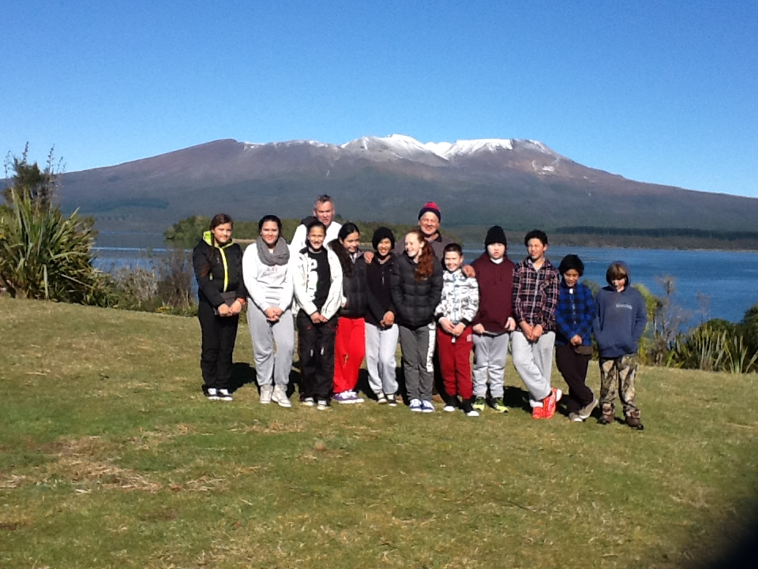
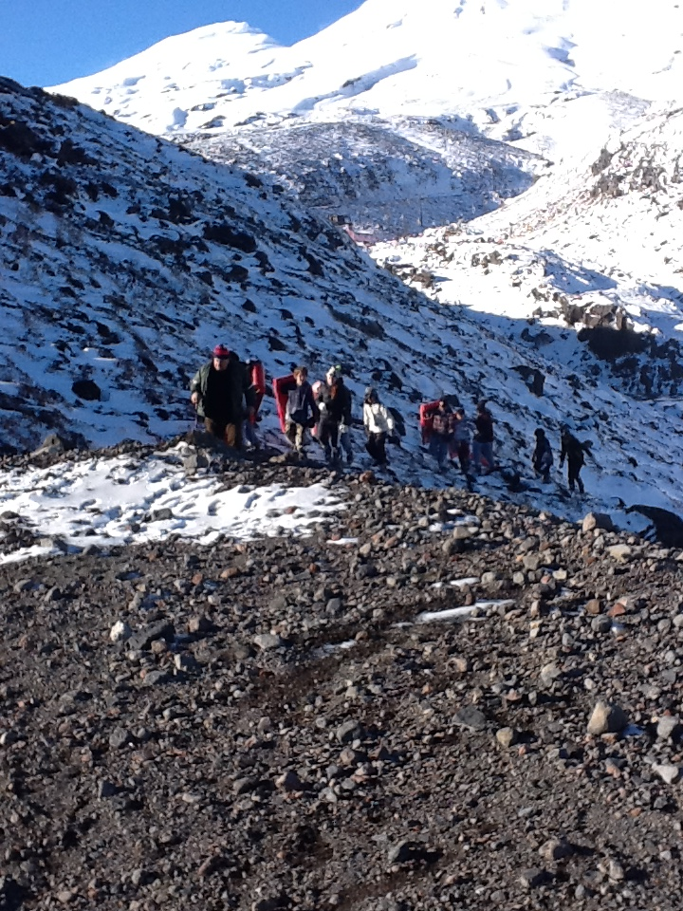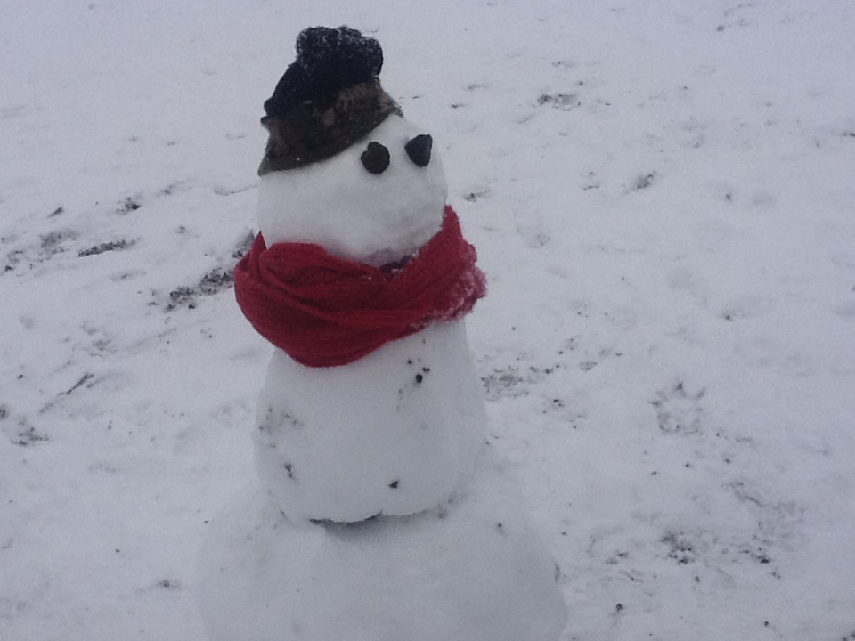
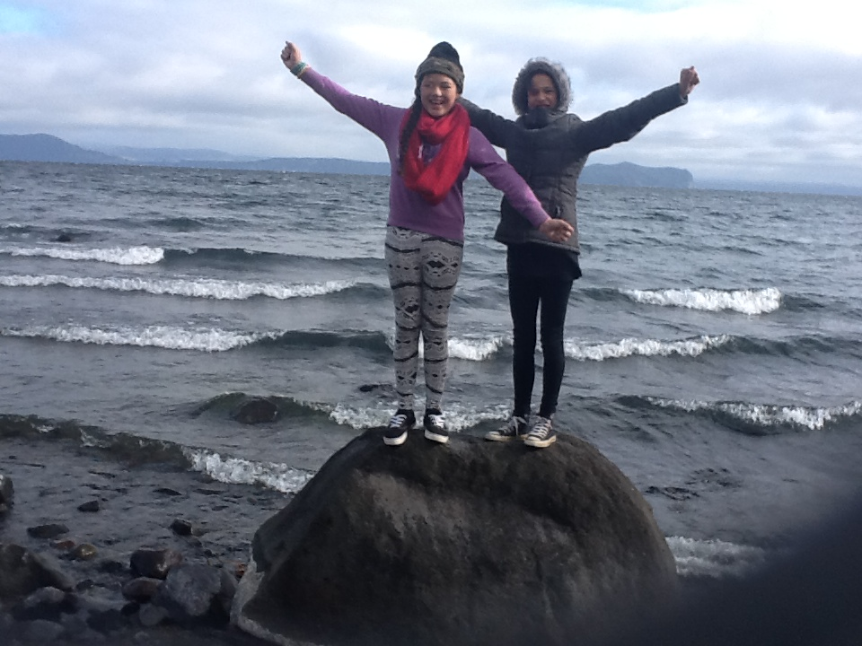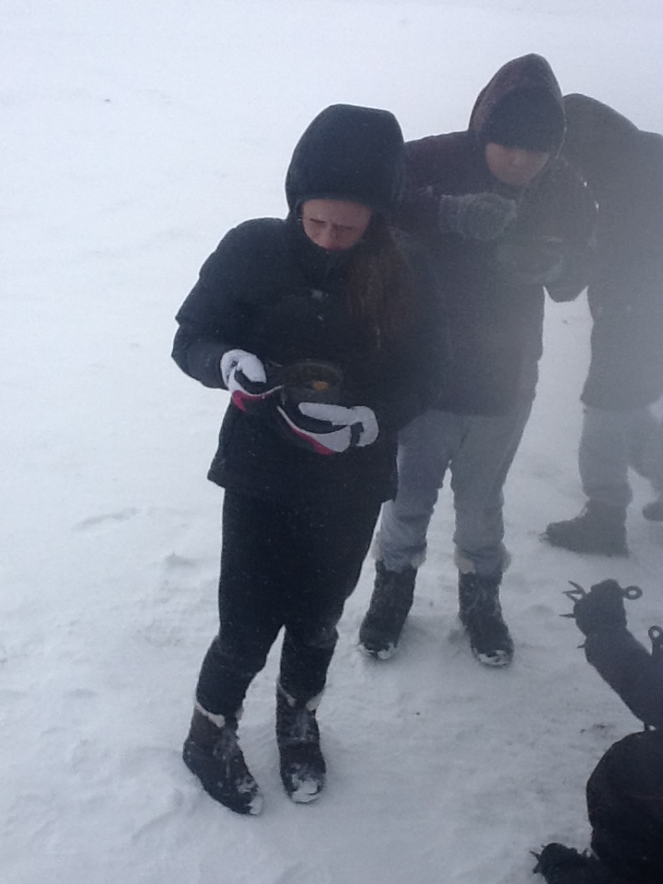
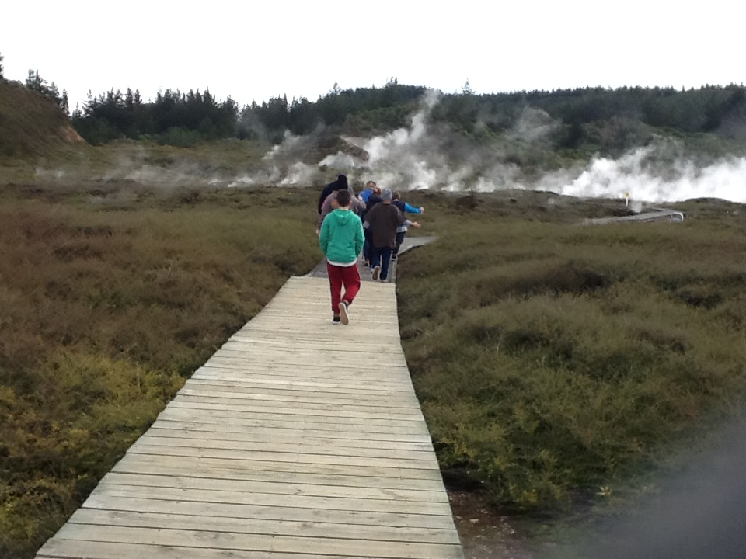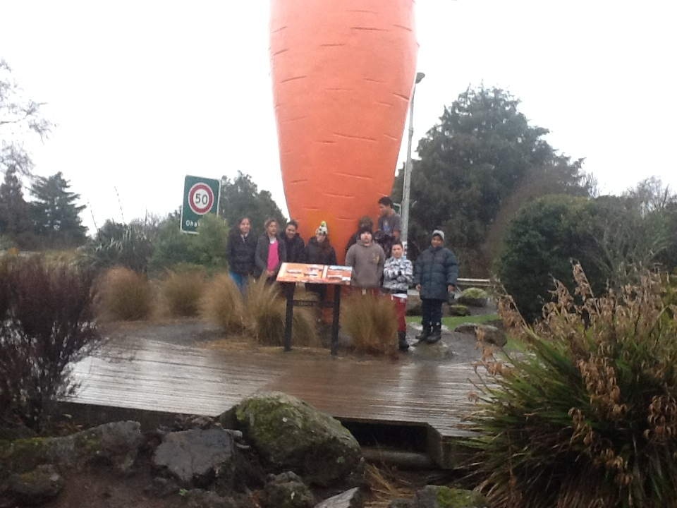
Arohanui Hurimae & Henare

